2017第十六次建筑与文化国际学术讨论会
THE 16TH INTERNATIONAL CONFERENCE OF ARCHITECTURE AND CULTURE
ICAC 2017

会议手册
CONFERENCE PROGRAMME

苏州大学金螳螂建筑学院
SCHOOL OF ARCHITECTURE，SOOCHOW UNIVERSITY
2017.9.27-2017.9.29丨中国 苏州
27-29 SEPTEMBER 2017 丨SUZHOU, CHINA

目录 CONTENTS
简介
INTRODUCTION

会议主题
CONFERENCE THEME

嘉宾名单
GUEST LIST

日程
SCHEDULE

会议议程
CONFERENCE AGENDA

住宿信息
ACCOMMODATION INFORMATION

会议费用
CONFERENCE FEE

会务联络
CONTACT

地图
MAPS

生活贴士
TIPS

致谢
ACKNOWLEDGEMENTS

简介
INTRODUCTION

简介 INTRODUCTION

建筑与文化国际（全国）学术讨论会是由中国建筑学会史学分会建筑与文化学术委员会主办，每一至两年举办一次的国际（全国）建筑学术交流会议。建筑与文化会议起源于 1989 年，于长沙举办第一次讨论会。第十六次建筑与文化国际学术讨论会于 2017年 9 月 27日至 29 日在苏州大学举行。
The International (National) Conference of Architecture and Culture, hosted by the Academic Committee of Architecture and Culture, Architectural Society of China (Architecture Historiography Branch), is a biannual (annual) platform to promote academic communication on architecture and culture. It started in 1989, and the 1st conference took place in Changsha, Hunan Province. The 16th International Conference of Architecture and Culture will be held from September 27-29, 2017 at Soochow University, Suzhou, China.
建筑与文化会国际学术讨论会的举办历史如下:
An outline of previous conferences is listed below:

时间 YEAR | 地点 LOCATION
第 01 届 1989 年  1st conference (1989) | 湖 南·长沙  Changsha · Hunan Province
第 02 届 1992 年  2nd conference (1992) | 河 南·三门峡  Sanmenxia· Henan Province
第 03 届 1994 年  3rd conference (1994) | 福 建·泉 州  Quanzhou · Fujian Province
第 04 届 1996 年  4th conference (1996) | 湖 南·长 沙  Changsha · Hunan Province
第 05 届 1998 年  5th conference (1998) | 云 南·昆 明  Kunming · Yunnan Province
第 06 届 2000 年  6th conference (2000) | 四 川·成 都  Chengdu · Sichuan Province
第 07 届 2002 年  7th conference (2002) | 江 西·庐 山  Lushan · Jiangxi Province
第 08 届 2004 年  8th conference (2004) | 浙 江·杭 州  Hangzhou · Zhejiang Province
第 09 届 2006 年  9th conference (2006) | 河 南·洛 阳  Luoyang · Henan Province
第 10 届 2008 年  10th conference (2008) | 陕 西·西 安  Xi’an · Shaanxi Province
第 11 届 2009 年  11th conference (2009) | 湖 南·长 沙  Changsha · Hunan Province
第 12 届 2010 年  12th conference (2010) | 新 疆·乌鲁木齐  Urumqi · Xinjiang Province
第 13 届 2012 年  13th conference (2012) | 安 徽·合 肥  Hefei · Anhui Province
第 14 届 2014 年  14th conference (2014) | 吉 林·长 春  Changchun · Jilin Province
第 15 届 2016 年  15th conference (2016) | 四 川·成 都  Chengdu · Sichuan Province
第 16 届 2017 年  16th conference (2017) | 江苏·苏 州  Suzhou · Jiangsu Province

本次会议相关单位
ICAC2017 Sponsors and Organizers
主办单位：中国建筑学会史学分会建筑与文化学术委员会
承办单位：苏州大学金螳螂建筑学院
合办单位：清华大学建筑学院
东南大学建筑学院
同济大学建筑与城市规划学院
天津大学建筑学院
华南理工大学建筑学院
重庆大学建筑城规学院
哈尔滨工业大学建筑学院
西安建筑科技大学建筑学院
华中科技大学建筑与城市规划学院
南京大学建筑与城市规划学院
湖南大学建筑学院
浙江大学建筑工程学院
大连理工大学建筑与艺术学院
沈阳建筑大学建筑与规划学院
西南交通大学建筑与设计学院
福州大学建筑学院
昆明理工大学建筑与城市规划学院
协办单位： 联合国教科文组织亚太地区世界遗产培训与研究中心（苏州）
江苏省土木建筑学会
苏州市风景园林学会
支持单位： 中 海 地 产
金螳螂建筑装饰股份有限公司
中衡设计集团股份有限公司
启迪设计集团股份有限公司
苏州园林发展股份有限公司
苏州苏大建筑规划设计有限公司
媒体支持： 《建筑学报》、《新建筑》、《建筑师》、《世界建筑》、
《中国园林》、《中国名城》、《时代建筑》、《华中建筑》、
《世界建筑导报》、《西部人居环境学刊》、《城市建筑》、
《建筑与文化》、《南方建筑》等。
微信公众号： 中国建筑学会（chinaasc）、建筑学报（jianzhuxuebao）、
中国园林杂志（jcla1985）新建筑（xinjianzhu1983）、
有方空间（youfang502）、ABBS(ABBS02861998484)。

Host:
Academic Committee of Architecture and Culture, Architectural Society of China (Architecture Historiography Branch)
Organizer:
School of Architecture, Soochow University
Co-Organizers:
UNESCO WHITRAP (Suzhou)
Jiangsu Civil Engineering & Architectural Society
Suzhou Society of Landscape Architecture

会议主题
CONFERENCE THEME

会议主题 CONFERENCE THEME

建筑与文化学术讨论会宗旨
Objectives of the Conference

- 在时代流变与本体恒在的张力中探究建筑文化意涵；
- 在宏大叙事与微观日常的对话中展开建筑文化批判；
- 在史学考据与多元透视的思辨中引导建筑文化发展。
- To promote discussion on architectural culture, especially with respect to the tension between transformation and continuity;
- To encourage thoughtful critique on architectural culture both in its grand narrative and in its daily dialogues;
- To guide the development of architectural culture through research of historical methods and multidisciplinary approaches.

本次论坛主题：水乡 · 园林 · 城市
Themes of the Conference: Water Towns, Classic Gardens, Cities

- Z-1. 阐释与转译——园林
- Z-2. 地域建筑文化——水乡
- Z-1. Interpretation and Representation: Classic Gardens
- Z-2. Regional Architectural Culture: Water Towns

议题
- Y-1. 建筑（微）批评——明星建筑师的建筑
- Y-2. 建筑创作的文化策略——新型城镇化与建筑创作
- Y-3. 跨文化探索——多元文化碰撞与融汇
- Y-4. 青年自由论坛——城市更新与社区营造

Session Topics
- Y-1. (Flash talks on) Architecture Criticism: The Architecture of Star Architects
- Y-2. Cultural Strategies in Architectural Design: New Urbanization and Architectural Design
- Y-3. Cross-Cultural Investigations: Multi-Cultural Encounters and Integration
- Y-4. Youth Forum: Urban Renewal and Community Development

嘉宾名单
GUEST LIST

嘉宾名单 GUEST LIST

王建国  Wang Jianguo | 中国工程院院士，东南大学建筑学院教授  Academician of Chinese Academy of Engineering; Professor at the School of Architecture in Southeast University
孟建民  Meng Jianmin | 中国工程院院士，全国建筑设计大师，深圳市建筑设计研究总院有限公司总建筑师  Academician of Chinese Academy of Engineering; Master of Architectural Design in China; Chief Architect of the Shenzhen General Institute of Architectural Design and Research Co., Ltd.
吴庆洲  Wu Qingzhou | 华南理工大学建筑学院教授，建筑与文化委员会主席  Professor at the School of Architecture in South China University of Technology; Chairman of the Committee of Architecture and Culture
陆 琦  Lu Qi | 华南理工大学建筑学院教授，中国民族建筑研究会传统民居学术委员会主任委员  Professor at the School of Architecture in South China University of Technology; Chairman of the Academic Committee of Chinese Traditional Dwelling, National Architecture Institute of China
夏铸九  Hsia Chu-joe | 东南大学建筑学院教授，台湾大学建筑与城乡研究所名誉教授  Professor at the School of Architecture in Southeast University;  Honorary Professor of the Graduate Institute of Building & Planning in National Taiwan University
葛 明  Ge Ming | 东南大学建筑学院教授、副院长  Professor, Deputy Dean of the School of Architecture in Southeast University
李向锋  Li Xiangfeng | 东南大学建筑学院副教授、党委副书记、副院长  Associate professor, Deputy Party Secretary, Deputy Dean of the School of Architecture in Southeast University
李翔宁  Li Xiangning | 同济大学建筑与城市规划学院教授、副院长  Professor, Deputy Dean of the College of Architecture and Urban Planning in Tongji University
蔡永洁  Cai Yongjie | 同济大学建筑与城市规划学院教授、建筑学系主任  Professor, Director of the Department of Architecture, College of Architecture and Urban Planning in Tongji University
孔宇航  Kong Yuhang | 天津大学建筑学院教授、副院长  Professor, Deputy Dean of the School of Architecture in Tianjin University
张 昕  Zhang Xin | 清华大学建筑学院副教授、院长助理  Associate professor, Assistant to the Dean of the School of Architecture in Tsinghua University
李晓峰  Li Xiaofeng | 华中科技大学建筑与城市规划学院教授、副院长，《新建筑》主编，建筑与文化委员会主任  Professor, Deputy Dean of the School of Architecture and Urban Planning in Huazhong University of Science and Technology; Chief Editor of the journal New Architecture; Director of the Committee of Architecture and Culture
谭刚毅  Tan Gangyi | 华中科技大学建筑与城市规划学院教授、副院长，建筑与文化委员会秘书长  Secretary General of Committee of Architecture and Culture; Professor, Deputy Dean of the School of Architecture and Urban Planning in Huazhong University of Science and Technology
王维仁  Wang Weiren | 香港大学建筑系教授，王维仁建筑研究室主持人，美国建筑师学会会员  Professor of the Department of Architecture in the University of Hong Kong; Moderator of Wang Weijen Architecture; Member of American Institute of Architects
冯仕达  Stanislaus Fung | 香港中文大学建筑学院副教授、建筑学博士课程主任  Associate professor and Director of the MPhil-PhD Programme, School of Architecture, Chinese University of Hong Kong
刘少瑜  Siu Yu LAU | 新加坡国立大学教授，设计与环境学院建筑系副系主任  Professor, Deputy Director of the School of Design & Environment in National University of Singapore
Keonha Lee | 亚洲文化环境研究院院长，韩国忠清南道文化遗产委员会委员  Chairman of the Asian Cultural Environment Research Institute; Member of the Chungcheongnam-do Cultural Heritage Committee in Korea
褚冬竹  Chu Dongzhu | 重庆大学建筑城规学院教授、副院长  Professor, Deputy Dean of the Faculty of Architecture & Urban Planning in Chongqing University
段德罡  Duan Degang | 西安建筑科技大学建筑学院教授、副院长  Professor, Deputy Dean of the Architecture College in Xi’an University of Science and Technology
王 军  Wang Jun | 西安建筑科技大学建筑学院教授、建筑与环境研究所所长  Professor at the Architecture College, Director of the Institute of Architecture and Environment in Xi’an University of Science and Technology
刘 晖  Liu Hui | 西安建筑科技大学建筑学院教授  Professor at the Architecture College in Xi’an University of Science and Technology
靳亦冰  Jin Yibing | 西安建筑科技大学建筑学院副教授、中国民族建筑研究会民居建筑学术委员会副秘书长  Associate professor at the Architecture College in Xi’an University of Science and Technology; Deputy Secretary General of the Academic Committee of Chinese Traditional Dwelling, National Architecture Institute of China
崔文河  Cui Wenhe | 西安建筑科技大学艺术学院副教授  Associate professor at the Architecture College in Xi’an University of Science and Technology
魏春雨  Wei Chunyu | 湖南大学建筑学院教授、院长，建筑与文化委员会副主任  Professor, Dean of the School of Architecture in Hunan University; Deputy Director of the Committee of Architecture and Culture
徐 峰  Xu Feng | 湖南大学建筑学院教授、副院长  Professor, Deputy Dean of the School of Architecture in Hunan University
卢健松  Lu Jiansong | 湖南大学建筑学院副教授、建筑系系主任  Associate professor, Director of the Department of Architecture, School of Architecture in Hunan University
宋明星  Song Mingxing | 湖南大学建筑学院副教授、建筑系副系主任  Associate professor, Deputy Director of the Department of Architecture, School of Architecture in Hunan University
范 悦  Fan Yue | 大连理工大学建筑与艺术学院教授、院长  Professor, Dean of the School of Architecture & Fine Art in Dalian University of Technology
李世芬  Li Shifen | 大连理工大学建筑与艺术学院教授  Professor at the School of Architecture & Fine Art in Dalian University of Technology
胡 恒  Hu Heng | 南京大学建筑与城市规划学院教授，《建筑文化研究》主编  Professor at the School of Architecture and Urban Planning in Nanjing University; Chief Editor of the journal Studies of Architecture & Culture
朱 玲  Zhu Ling | 沈阳建筑大学建筑与规划学院教授、党委书记  Professor, Party Secretary of the School of Architecture and Urban Planning in Shenyang Jianzhu University
吕健梅  Lv Jianmei | 沈阳建筑大学建筑与规划学院教授  Professor at the School of Architecture and Urban Planning in Shenyang Jianzhu University
张 园  Zhang Yuan | 沈阳建筑大学建筑与规划学院副教授  Associate professor at the School of Architecture and Urban Planning in Shenyang Jianzhu University
李丹阳  Li Danyang | 沈阳建筑大学建筑与规划学院讲师  Lecturer at the School of Architecture and Urban Planning in Shenyang Jianzhu University
沈中伟  Shen Zhongwei | 西南交通大学建筑与艺术学院教授、院长  Professor, Dean of the School of Architecture and Design in Southwest Jiaotong University
刘春尧  Liu Chunyao | 西南交通大学建筑与艺术学院副教授  Associate professor at the School of Architecture and Design in Southwest Jiaotong University
关瑞明  Guan Ruiming | 福州大学建筑学院教授  Professor at the School of Architecture in Fuzhou University
杨大禹  Yang Dayu | 昆明理工大学建筑与城市规划学院教授、副院长  Professor, Deputy Dean of the Faculty of Architecture and City Planning in Kunming University of Science and Technology
查金荣  Zha Jinrong | 启迪设计集团股份有限公司总裁兼总建筑师  CEO, chief architect at the Tus-Design Group Co.,Ltd
张应鹏  Zhang Yingpeng | 九城都市建筑设计有限公司合伙人、总建筑师，东南大学建筑学院兼职教授  Partner, Chief Architect of 9 Town Studio; visiting professor at the School of Architecture in Southeast University
陈 霖  Chen Lin | 苏州大学凤凰传媒学院教授，苏州大学新媒介与青年文化研究中心副主任  Professor at the Phoenix Communication College; Deputy Director of New Media & Youth Culture Study Center in Soochow University
徐永利  Xv Yongli | 苏州科技大学建筑学院建筑学系主任、副教授  Associate professor, Dean of the Department of Architecture, School of Architecture and Urban Planning in Suzhou University of Science and Technology
童乔慧  Tong Qiaohui | 武汉大学城市设计学院教授  Professor at the City College in Wuhan University
马 明  Ma Ming | 内蒙古科技大学建筑学院教授、院长  Professor, Dean of Architectural Institute in Inner Mongolia University of Science & Technology
孔 敬  Kong Jing | 内蒙古科技大学建筑学院副教授  Associate professor at the School of Architecture in Inner Mongolia University of Science & Technology
王家浩  Wang Jiahao | 建筑与艺术评论人、策展人，“BLOOM绽”联合策划团队发起人  Critic, curator of architecture and art; Founder of the “Bloom” Curatorial Team
Hisham Youssef | 美国建筑师协会(AIA)会员，英国皇家建筑师协会(RIBA)会员，上海ECC建筑设计有限公司合伙人，苏州大学建筑学院外籍教师  Member of the American Institute of Architects (AIA), member of the Royal Institute of British Architects (RIBA); Partner of Shanghai ECC Architectural Design Co. Ltd.
Federic Bereder | 法国注册建筑师，日本一级注册建筑师，苏州大学建筑学院外籍教师  Registered architect in France; 1st Class Registered Architect in Japan; Foreign teacher of the School of Architecture in Soochow University
Kiumars Roshanzamir | 丹麦独立建筑师，莱佛士国际设计学院高级讲师，苏州大学建筑学院外籍教师  Independent architect in Denmark, Senior lecturer at the Raffles Design Institute, foreign teacher at the School of Architecture in Soochow University
周 淼  Zhou Miao | 浙江大学城市学院讲师，教研室副主任  Lecturer at the City College in Zhejiang University, Deputy Director of the Teaching and Research Section
都 铭  Du Ming | 浙江工业大学建筑工程学院建筑系，高级工程师  Senior engineer at the Department of Architecture, College of Civil Engineering and Architecture in Zhejiang University of Technology
张 云  Zhang Yun | 浙江大学农业与生物技术学院园林研究所，副教授  Associate professor in Landscape Architecture, College of Agriculture & Biotechnology in Zhejiang University
王 宇  Wang Yu | 山东建筑大学建筑城规学院讲师，山东建筑大学无障碍研究中心秘书长  Lecturer at the School of Architecture and Urban Planning, Secretary General of the Research Center on Barrier-Free Design in Shandong Jianzhu University
顾勇新  Gu Yongxin | 中国建筑学会监事会监事，教授级高工  Professor-level senior engineer, Supervisor in the Supervisory Board of the Architectural Society of China
赵有岗  Zhao Yougang | 中海地产（苏州）有限公司董事，副总经理  Director, Deputy General Manager of Zhonghai Real Estate (Suzhou) Co. Ltd.
周苏宁  Zhou Suning | 苏州市风景园林学会副理事长兼秘书长  Vice President, Secretary General of Suzhou Society of Landscape Architecture
徐学民  Xu Xuemin | 苏州市风景园林学会副理事长兼常务副秘书长  Vice President, Deputy Secretary General of Suzhou Society of Landscape Architecture
吴琛瑜  Wu Chenyu | 联合国教科文组织亚太地区世界遗产培训与研究中心（苏州）主任  Director of the World Heritage Institute of Training and Research for Asian and the Pacific Region under the auspices of UNESCO (Suzhou)
王沁苒  Wang Qinran | 联合国教科文组织亚太地区世界遗产培训与研究中心（苏州）培训部主任  Director of the Department of Training, World Heritage Institute of Training and Research for Asian and the Pacific Region under the auspices of UNESCO (Suzhou)
施春煜  Shi Chunyu | 联合国教科文组织亚太地区世界遗产培训与研究中心（苏州）监测部主任  Director of the Monitoring Department, World Heritage Institute of Training and Research for Asian and the Pacific Region under the auspices of UNESCO (Suzhou)
蒋叶琴  Jiang Yeqin | 联合国教科文组织亚太地区世界遗产培训与研究中心（苏州）办公室主任  Office Manager at the World Heritage Institute of Training and Research for Asian and the Pacific Region under the auspices of UNESCO (Suzhou)
俞 红  Yu Hong | 《华中建筑》主编  Chief Editor of the journal Huazhong Architecture
王莉慧  Wang Lihui | 《建筑师》 主编  Chief Editor of the journal Architect
柳 涛  Liu Tao | 《建筑师》 运营总监  Chief operating officer of the journal Architect
方 盈 & 明 星  Fang Ying &  Ming Xing | 《新建筑》杂志社编辑，建筑与文化学术委员会秘书  Editors of the journal New Architecture, Secretaries of the Academic Committee of Architecture and Culture

日程
SCHEDULE

日程 SCHEDULE
报到日 - 9月27日 周三
【下午】报到
14:00-20:00 会议代表报到
【晚间】工作会议
20:00-21:00 大会预备会

Arriving Day－Wed. 27 Sep. 2017
Afternoon: Registration
14:00-20:00 Registration of participants
Evening: Committee Meeting
20:00-21:00 Preparatory Meeting

会议第一天－9月28日 周四
【上午】开幕式、主题报告（苏州大学金螳螂建筑学院学术交流中心梦溪厅）
09:00-09:40 会议开幕式
10:00-11:40 主题报告
【中午】就餐、休息
11:40-13:30 工作餐 （学术交流中心）
【下午】主题报告 （苏州大学金螳螂建筑学院学术交流中心梦溪厅）
13:30-15:30 主题报告
15:30-15:50 茶歇
15:50-17:30 主题报告
【晚间】晚宴 (西交利物浦国际会议中心酒店)

Conference Day 1－Thur. 28 Sep. 2017
Morning: Opening Ceremony & Keynote Speeches (Gold Mantis School of Architecture Academic Exchange Center)
09:00-09:40 Opening Ceremony
10:00-11:40 Keynote Speeches
Lunch Break
11:40-13:30 Lunch (Academic Exchange Center)
Afternoon: Keynote Speeches
13:30-15:30 Keynote Speeches
15:30-15:50 Tea Break
15:50-17:30 Keynote Speeches
Evening: Dinner (Xi’an Jiaotong-Liverpool International Conference Center)

会议第二天－9月29日 周五
【上午】分论坛及议题讨论（苏州大学金螳螂建筑学院学术交流中心）
9:00-10:00 分组报告及讨论
分会场A （地域建筑文化——水乡）
分会场B （阐释与转译——园林）
分会场C （建筑创作的文化策略 & 城市更新与社区营造）
分会场D （跨文化探索——多元文化碰撞与融汇）
10:00-10:15 茶歇
10:15-11:00 分组报告及讨论
分会场A （地域建筑文化——水乡）
分会场B （阐释与转译——园林）
分会场C （建筑创作的文化策略 & 城市更新与社区营造）
分会场D （跨文化探索——多元文化碰撞与融汇）
11:00-11:30茶歇
11:30-12:20 闭幕式
【中午】就餐
12:20-13:30 工作餐 （学院学术交流中心）
【下午】参观或离会

Conference Day 2－Thur. 29 Sep. 2017
Morning: Parallel Sessions (Gold Mantis School of Architecture Academic Exchange Center)
9:00-10:00 Parallel Sessions and Discussion
Session A (Regional Architectural Culture: Water Towns)
Session B (Interpretation and Representation: Classic Gardens)
Session C (Cultural Strategies in Architectural Design & Urban Renewal and Community Development)
Session D (Cross-Cultural Investigations: Multi-Cultural Encounters and Integration)
10:00-10:15 Tea Break
10:15-11:00 Parallel Sessions and Discussion
Session A (Regional Architectural Culture: Water Towns)
Session B (Interpretation and Representation: Classic Gardens)
Session C (Cultural Strategies in Architectural Design & Urban Renewal and Community Development)
Session D (Cross-Cultural Investigations: Multi-Cultural Encounters and Integration)
11:00-11:30 Tea Break
11:30-12:20 Closing Ceremony
Lunch Break
12:20-13:30 Lunch (Academic Exchange Center)
Afternoon: Departure

会议议程
CONFERENCE AGENDA

会议议程 CONFERENCE AGENDA

会议第一天9月28日 周四｜Day 1：Thu. 28 Sep. 2017
上午9:00｜Morning 9:00

开幕式：苏州大学金螳螂建筑学院学术交流中心 梦溪厅 ｜ Opening Ceremony: Mengxi Hall, Gold Mantis School of Architecture Academic Exchange Center  主持人：黄志斌 | Host: Huang Zhibin  苏州大学建筑学院教授、党委书记 |  |  |  | 9:00-9:40
序号  NO. | 发言人  SPEAKER | 单位／职务  AFFILIATION/POSITION | 题目  TITLE | 时间  TIME
A-1 | 吴永发  Wu Yongfa | 苏州大学金螳螂建筑学院教授、院长  Professor，Dean of the School of Architecture，Soochow University | 欢迎辞  Salutatory | 9:00-9:10
A-2 | 王建国  Wang Jianguo | 中国工程院院士，  东南大学建筑学院教授  Academician of Chinese Academy of Engineering；Professor，School of Architecture，Southeast University | 开幕致辞  Opening speech | 9:10-9:20
A-3 | 吴庆洲  Wu Qingzhou | 华南理工大学建筑学院教授，  建筑与文化委员会主席  Professor，School of Architecture，South China University of Technology；Chairman of Committee of Architecture and Culture | 开幕致辞  Opening speech | 9:20-9:30
A-4 | 谭刚毅  Tan Gangyi | 建筑与文化委员会秘书长，  华中科技大学建筑与城市规划学院教授、副院长  Secretary General of the Committee of Architecture and Culture；Professor，Deputy Dean of the School of Architecture and Urban Planning，Huazhong University of Science and Technology | 建筑与文化年会历程、展望  Overview of the development of ICAC | 9:30-9:40
全体参会人员合影（学术交流中心前）  Event Photography of Conference Participants（In Front of the Academic Exchange Center） |  |  |  | 9:40-10:00

上午主题报告：苏州大学金螳螂建筑学院学术交流中心 梦溪厅 | Keynote Speeches (Morning): Mengxi Hall, Gold Mantis School of Architecture Academic Exchange Center  主持人：李翔宁| Host: Li Xiangning  同济大学建筑与城市规划学院教授、副院长 |  |  |  | 10:00-11:40
序号  NO. | 发言人  SPEAKER | 单位／职务  AFFILIATION/POSITION | 题目  TITLE | 时间  TIME
B-1 | 吴庆洲  Wu Qingzhou | 华南理工大学建筑学院教授，  建筑与文化委员会主席  Professor ，School of Architecture，South China University of Technology；Chairman of Committee of Architecture and Culture | 华夏遗产之珍——古城水系  Treasure of China’s Heritage: Urban Canal Systems in Ancient China | 10:00-10:20
B-2 | 夏铸九  Hsia Chu-joe | 东南大学建筑学院教授，  台湾大学建筑与城乡研究所名誉教授  Professor，School of Architecture，Southeast University；Honorary Professor of the Graduate Institute of Building & Planning in National Taiwan University | 反思比较地景史  A Reflection on Comparative Landscape Histories | 10:20-10:40
B-3 | 李晓峰  Li Xiaofeng | 华中科技大学建筑与城市规划学院教授、  副院长，《新建筑》主编，  建筑与文化委员会主任  Professor，Deputy Dean of the School of Architecture and Urban Planning，Huazhong University of Science and Technology；Chief Editor of the journal New Architecture; Director of the Committee of Architecture and Culture | 聚落认知与乡建误区  Cognitive Analysis of Traditional Settlements and Misunderstandings of Vernacular Development | 10:40-11:00
B-4 | 魏春雨  Wei Chunyu | 湖南大学建筑学院教授、院长，  建筑与文化委员会副主任  Professor，Dean of the School of Architecture，Hunan University；Deputy Director of the Committee of Architecture and Culture | 原型图式  Archetypal Graphic Schemes | 11:00-11:20
B-5 | 吴永发  Wu Yongfa | 苏州大学金螳螂建筑学院教授、院长  Professor，Dean of the School of Architecture，Soochow University | “园中园”——共享园林的创意与营造实践  “Garden in the Garden”: Innovation and Practice of Shared Gardens | 11:20-11:40
工作餐 (学术交流中心) & 学院自主参观  Lunch (Academic Exchange Center) & University Tour |  |  |  | 11:40-13:30

下午主题报告：苏州大学金螳螂建筑学院学术交流中心 梦溪厅 ｜Keynote Speeches (Afternoon): Mengxi Hall, Gold Mantis School of Architecture Academic Exchange Center  主持人：李晓峰| Host: Li Xiaofeng  华中科技大学建筑与城市规划学院教授、副院长，  《新建筑》主编，建筑与文化委员会主任 |  |  |  | 13:30-15:30
序号  NO. | 发言人  SPEAKER | 单位／职务  AFFILIATION/POSITION | 题目  TITLE | 时间  TIME
C-1 | 孔宇航  Kong Yuhang | 天津大学建筑学院教授、副院长  Professor，Deputy Dean of the School of Architecture，Tianjin University | 空间的路径  The Path of Space | 13:30-13:50
C-2 | 李翔宁  Li Xiangning | 同济大学建筑与城市规划学院教授、副院长  Professor，Deputy Dean of the College of Architecture and Urban Planning，Tongji University | 上海的当代居住文化 Contemporary Residential Culture in Shanghai | 13:50-14:10
C-3 | 葛 明  Ge Ming | 东南大学建筑学院教授、副院长  Professor，Deputy Dean of the School of Architecture，Southeast University | 园林方法提要  A Summary of Methods for Garden Design | 14:10-14:30
C-4 | 胡 恒  Hu Heng | 南京大学建筑与城市规划学院教授，  《建筑文化研究》主编  Professor，School of Architecture and Urban Planning，Nanjing University；Chief Editor of the journal Studies of Architecture & Culture | 明代南京园林画初探  A Preliminary Study of Nanjing Garden Paintings of the Ming Dynasty | 14:30-14:50
C-5 | 冯仕达  Stanislaus Fung | 香港中文大学建筑学院副教授、建筑学博士课程主任  Associate professor and Director of the MPhil-PhD Programme，School of Architecture，Chinese University of Hong Kong | 尺度含糊与“外面的外面”：苏州网师园精读  Scalar Ambiguity and the “Outside of the Outside”: A Close Reading of the Garden of the Master of the Nets in Suzhou | 14:50-15:10
C-6 | 褚冬竹  Chu Dongzhu | 重庆大学建筑城规学院教授、副院长  Professor，Deputy Dean of the Faculty of Architecture & Urban Planning，Chongqing University | 小城复兴：现实、思考、路径  Regeneration of a Small County: Reality, Reflection, Approaches | 15:10-15:30
茶歇  Tea Break |  |  |  | 15:30-15:50

下午主题报告：苏州大学金螳螂建筑学院学术交流中心 梦溪厅 ｜Keynote Speeches (Afternoon): Mengxi Hall, Gold Mantis School of Architecture Academic Exchange Center  主持人：褚冬竹| Host: Chu Dongzhu  重庆大学建筑城规学院教授、副院长 |  |  |  | 15:50-17:30
序号  NO. | 发言人  SPEAKER | 单位／职务  AFFILIATION/POSITION | 题目  TITLE | 时间  TIME
D-1 | 刘少瑜  Siu Yu LAU | 新加坡国立大学教授，设计与环境学院建筑系副系主任  Professor，Deputy Director of the School of Design & Environment，National University of Singapore | 太平山下的香港大学——超越绿色、孕育生态、迈向共享  What Lies at the Foot of Tai Ping Shan: A Story of a Sustainable Community | 15:50-16:10
D-2 | 陈 霖  Chen Lin | 苏州大学凤凰传媒学院教授，苏州大学新媒介与青年文化研究中心副主任  Professor，the Phoenix Communication College；Deputy Director of New Media & Youth Culture Study Center，Soochow University | 公共艺术：城市阈限空间的文化脚注——以苏州工业园区城市雕塑为考察对象  Public Art: Cultural Footnotes for Urban Liminal Space —— An Investigation into the Urban Sculptures in Suzhou Industrial Park | 16:10-16:30
D-3 | 张 昕  Zhang Xin | 清华大学建筑学院副教授、院长助理  Associate professor，Assistant to the Dean of the School of Architecture，Tsinghua University | 基于动态气象参数模型的中国传统建筑天然光环境研究  Daylighting in Traditional Chinese Architecture: Based on Dynamic Meteorological Data Model | 16:30-16:50
D-4 | 杨大禹  Yang Dayu | 昆明理工大学建筑与城市规划学院  教授、副院长  Professor, Deputy Dean of the Faculty of Architecture and City Planning in Kunming University of Science and Technology | 不是园林，胜似园林  ——浅议腾冲一中校园环境的景观设计思考A Garden-inspired Campus: A Discussion on the Landscape Design for Tengchong No.1 Middle School | 16:50-17:10
D-5 | 王维仁  Wang Weiren | 香港大学建筑系教授，王维仁建筑研究室主持人，美国建筑师学会会员  Professor of the Department of Architecture，the University of Hong Kong；Moderator of Wang Weijen Architecture；Member of American Institute of Architects | 山水叙事：松阳双村记  Rebuilding Community's Landscape Narrative: a Tale of Twins Villages in Songyang | 17:10-17:30
晚宴 (西交利物浦国际会议中心酒店)
Formal Dinner (Xi’an Jiaotong-Liverpool International Conference Center)

会议第二天9月29日 周五｜Day 2：Fri. 29 Sep. 2017
分会场A｜ Parallel Session A
地域建筑文化——水乡
苏州大学金螳螂建筑学院学术交流中心 一楼一元厅｜ Yiyuan Hall (1F), Gold Mantis School of Architecture Academic Exchange Center  主持人：汤晔峥 | Host: Tang Yezheng  苏州大学建筑学院副教授、历史建筑与遗产保护研究所所长 |  |  |  | 9:00-10:00
序号  NO. | 发言人  SPEAKER | 单位  AFFILIATION | 题目  TITLE | 时间  TIME
A-1 | 余亮 | 苏州大学 | 浅析文化背景下中国传统民居研究的多学科与数据思维 | 9:00-9:15
A-2 | 都铭 | 浙江工业大学 | 文化遗产的建筑保护与应急干预——基于西湖三潭石塔的反思 | 9:15-9:30
A-3 | 周淼 | 浙江大学城市学院 | 宋金时期晋中地区通柱式连架厅堂结构形式调查与初步分析 | 9:30-9:45
A-4 | 高文娟 | 东南大学 | 《吴中水利全书》解读 | 9:45-10:00
茶歇  Tea Break |  |  |  | 10:00-10:15
苏州大学金螳螂建筑学院学术交流中心 一楼一元厅｜ Yiyuan Hall (1F), Gold Mantis School of Architecture Academic Exchange Center  主持人：徐俊丽| Host: Xu Junli  苏州大学建筑学院讲师，同济大学博士 |  |  |  | 10:15-11:00
A-5 | 陈晓琴 | 西南交通大学 | 德源镇清水河公园滨河绿地景观评价及设计优化 | 10:15-10:30
A-6 | 徐文浩 | 湖南大学 | 建筑地域性形成过程中的非理性因素——以湘西长田地区为例 | 10:30-10:45
A-7 | 聂倩 | 西安建筑科技大学 | 四川鲜水河流域拉日马石板藏寨传统民居初探 | 10:45-11:00
茶歇  Tea Break |  |  |  | 11:00-11:30

会议第二天9月29日 周五｜Day 2：Fri. 29 Sep. 2017
分会场B ｜ Parallel Session B
阐释与转译——园林

苏州大学金螳螂建筑学院学术交流中心 一楼融合厅 ｜ Ronghe Hall (1F), Gold Mantis School of Architecture Academic Exchange Center  主持人：郭明友 | Host: Guo Mingyou  苏州大学建筑学院副教授、风景园林系执行主任 |  |  |  | 9:00-10:00
序号  NO. | 发言人  SPEAKER | 单位  AFFILIATION | 题目  TITLE | 时间  TIME
B-1 | 张圆 | 沈阳建筑大学 | 陵墓类公园声景和谐性及提升策略研究——以沈阳北陵公园为例 | 9:00-9:15
B-2 | 徐永利 | 苏州科技大学 | 借阅园林——黑格尔美学视角下的江南私园 | 9:15-9:30
B-3 | 周功钊 | 中国美术学院 | “嫏嬛福地”与藏书楼园林——文学、图像与在场的解读 | 9:30-9:45
B-4 | 王笑石 | 天津大学 | 乾隆时期皇家园林对江南园林写仿的三个阶段——以四座北方《四库全书》藏书楼为例 | 9:45-10:00
茶歇  Tea Break |  |  |  | 10:00-10:15
苏州大学金螳螂建筑学院学术交流中心 一楼融合厅｜ Ronghe Hall (1F), Gold Mantis School of Architecture Academic Exchange Center  主持人：王珲| Host: Wang Hui  苏州大学建筑学院讲师，同济大学博士 |  |  |  | 10:15-11:00
B-5 | 姚舒然 | 东南大学 | 从《慧山记》与《慧山记续编》看无锡惠山明中期以后的变化 | 10:15-10:30
B-6 | 李莹 | 武汉大学 | 《牡丹亭》中的江南园林 | 10:30-10:45
B-7 | 陈国瑞 | 北京工业大学 | “ 中体西用 ” 下近代江南园林建构中的文化反思——以扬州何园为例 | 10:45-11:00
茶歇  Tea Break |  |  |  | 11:00-11:30

会议第二天9月29日 周五｜Day 2：Fri. 29 Sep. 2017
分会场C｜ Parallel Session C
建筑创作的文化策略 & 城市更新与社区营造
苏州大学金螳螂建筑学院学术交流中心 二楼五行厅 ｜ Wuxing Hall (2F), Gold Mantis School of Architecture Academic Exchange Center  主持人：李向锋 | Host: Li Xiangfeng  东南大学建筑学院副教授、党委副书记、副院长 |  |  |  | 9:00-10:00
序号  NO. | 发言人  SPEAKER | 单位  AFFILIATION | 题目  TITLE | 时间  TIME
C-1 | 宋明星 | 湖南大学 | 拾光:一种简明易行的竹建构美学——楼纳竹结构建造节对活化乡村文化的探索 | 9:00-9:15
C-2 | 孙磊磊 | 苏州大学 | “微距城市”视角下的传统民居控保改造研究 | 9:15-9:30
C-3 | 吕健梅 | 沈阳建筑大学 | 基于城市记忆的沈阳铁西工业区更新与改造策略研究 | 9:30-9:45
C-4 | 王家浩 | 策展人 | 生产者的对峙——以“总体剧场”为例 | 9:45-10:00
茶歇  Tea Break |  |  |  | 10:00-10:15
苏州大学金螳螂建筑学院学术交流中心 二楼五行厅｜ Wuxing Hall (2F), Gold Mantis School of Architecture Academic Exchange Center  主持人：潘一婷 | Host: Pan Yiting  苏州大学建筑学院讲师，英国剑桥大学博士 |  |  |  | 10:15-11:00
C-5 | 周秀峰 | 西安建筑科技大学 | 内蒙古地区博物馆类建筑的地域性创作方法解析 | 10:15-10:30
C-6 | 文静 | 湖南大学 | 湘西红石林老司岩村自建住宅的平面演化 | 10:30-10:45
C-7 | 钱俊超 | 华中科技大学 | 快速城镇化中小城镇建筑外墙面宣传设计的传统传承与创新——以武汉金口古镇为例 | 10:45-11:00
茶歇  Tea Break |  |  |  | 11:00-11:30

会议第二天9月29日 周五｜Day 2：Fri. 29 Sep. 2017
分会场D ｜ Parallel Session D
跨文化探索——多元文化碰撞与融汇
苏州大学金螳螂建筑学院学术交流中心 二楼融会厅｜ Ronghui Hall (2F), Gold Mantis School of Architecture Academic Exchange Center  主持人：张昕 | Host: Zhang Xin  清华大学建筑学院副教授、院长助理 |  |  |  | 9:00-10:00
序号  NO. | 发言人  SPEAKER | 单位  AFFILIATION | 题目  TITLE | 时间  TIME
D-1 | 童乔慧 | 武汉大学 | 从传统私家园林到现代化城市公园——澳门卢氏娱园研究 | 9:00-9:15
D-2 | 申绍杰 | 苏州大学 | 基于材料与结构的乡土建构 | 9:15-9:30
D-3 | 崔文河 | 西安建筑科技大学 | 多民族聚居区建筑文化保护传承研究 | 9:30-9:45
D-4 | 毛琳箐 | 石家庄铁道大学 | 基于文化扩散与整合机制的贵州传统建筑景观研究 | 9:45-10:00
茶歇  Tea Break |  |  |  | 10:00-10:15
苏州大学金螳螂建筑学院学术交流中心 二楼融会厅 ｜ Ronghui Hall (2F), Gold Mantis School of Architecture Academic Exchange Center  主持人： 张玲玲 | Host: Zhang Lingling  苏州大学建筑学院讲师，同济大学博士 |  |  |  | 10:15-11:00
D-5 | 檀丹丹 | 中南大学 | 浅析基于“敬惜字纸”信仰的惜字塔建筑文化——以长沙市及其周边地区为例 | 10:15-10:30
D-6 | 李佳静 | 内蒙古科技大学 | 多元文化碰撞与融汇下内蒙古农牧交错地带居住建筑的演变——以包头市固阳县下湿壕村为例 | 10:30-10:45
D-7 | 黄文 | 华南理工大学 | 乡村文化保护中的苗族民居建造方式演变的连续性研究——以贵州省陇戛苗寨为例 | 10:45-11:00
茶歇  Tea Break |  |  |  | 11:00-11:30

会议第二天9月29日 周五｜Day 2：Fri. 29 Sep. 2017
大会闭幕式｜ Closing Ceremony
闭幕式：苏州大学金螳螂建筑学院学术交流中心 梦溪厅 ｜Closing Ceremony: Mengxi Hall, Gold Mantis School of Architecture Academic Exchange Center  主持人： 雷诚 | Host: Lei Cheng  苏州大学金螳螂建筑学院副教授、副院长 |  |  |  | 11:30-12:20
序号  NO. | 发言人  SPEAKER | 单位  AFFILIATION | 内容  TITLE | 时间  TIME
E-1 | 分会场主持人  Hosts of Parallel Sessions  （汤晔峥、郭明友、李向锋、张昕） |  | 总结介绍分会场宣讲情况  Summary of the Parallel Sessions | 11:30-11:50
E-2 | 吴庆洲  Wu Qingzhou | 华南理工大学建筑学院教授，  建筑与文化委员会主席  Professor at the School of Architecture in South China University of Technology; Chairman of Committee of Architecture and Culture | 委员会主席闭幕总结  Closing summary by Committee Chairman | 11:50-12:05
E-3 | 闭幕式致辞 & 第十七次会议承办单位授旗仪式  Closing Speech & Flag Presentation Ceremony |  |  | 12:05-12:20
工作餐 （学术交流中心）  Lunch Break (Academic Exchange Center) |  |  |  | 12:20-13:30
参观或离会
Departure

注：因航班、交通等原因，会议议程顺序会有微调，最终以会议现场为准。

住宿信息
ACCOMMODATION INFORMATION

邀请嘉宾：入住西交利物浦国际会议中心酒店（四星级）。
其他参会人员：可请会务组代订西交利物浦国际会议中心酒店，或自行安排住宿酒店。
就餐：参会人员凭参会证就餐。

西交利物浦国际会议中心酒店
地址：江苏省苏州市工业园区仁爱路99号。
订房电话： 15151457598 沈经理
内部优惠价：标间380元/晚/间。
（请入住时报“苏州大学金螳螂建筑学院建筑与文化年会”）

会议费用
CONFERENCE FEE

费用说明：参会者1200元/人，学生600元/人（凭有效学生证）。
会务费含论文集、会议材料、会议期间工作餐，不含住宿交通费。

缴费方式：
1）转账：参会代表可于9月10日前通过银行柜面汇款方式转账。账户信息： （请务必注明“建筑文化会议+姓名”）
户名：苏州大学
账号：325601000010149002255
开户行：交通银行股份有限公司苏州苏大支行
2）现场刷卡：9月27日下午报到时现场缴纳。
3）发票领取或邮寄：
提前转账的参会人员：于9月29日10:00-11:30在苏州大学金螳螂建筑学院学术交流中心梦溪厅门口领取发票。
注意：请提前转账的参会人员务必在转账后及时通过短信或邮件联系财务组陈星老师（0512-65880187，15862510512，chenxing0812@suda.edu.cn）提供发票抬头、税号等开票信息。
报到现场刷卡的参会人员：发票将于会议结束后邮寄。

报到时间：9月27日（周三）下午14:00-20:00。

报到地点：西交利物浦国际会议中心，苏州工业园区独墅湖高教区仁爱路99号
（近苏州大学）（酒店电话：0512-86665555）
会务联络
CONTACT

地址： 苏州市工业园区仁爱路199号苏州大学独墅湖校区二期，
苏州大学金螳螂建筑学院（邮编：215123）

组委会邮箱：ICAC2017@126.com

会务组联系人：王 爽 0512-65882651，13812670521
swang@suda.edu.cn
陈 星 0512-65880187，15862510512
chenxing0812@suda.edu.cn<兼会务财务>

学术组联系人：孙磊磊 13501908552<统筹及协调>
潘一婷 13914032745
张玲玲 18352447611
地图
MAPS

校园位置
苏大校园实行半封闭式管理，请参会人员务必带好参会证。
苏州大学独墅湖校区地址：苏州市工业园区仁爱路199号

周边公共交通
公交：110、115、118、120、146、166、177、178、180、218、快线2号等。
站点：苏大公寓南区、苏大公寓北区、独墅湖体育馆东、西交大南、创意产业园、
人大国际学院、中科大、南大研究生院等。
地铁：地铁为2号线，松涛街站或月亮湾站下车。

校本部北门地址：苏州市干将东路333号，邮编215006。
公交站台：相门
公交线路：游5路、146路、178路、261路、32路、307路、40路、60路、
68路、518路、9路等，地铁1号线。

苏州市城市示意图↓

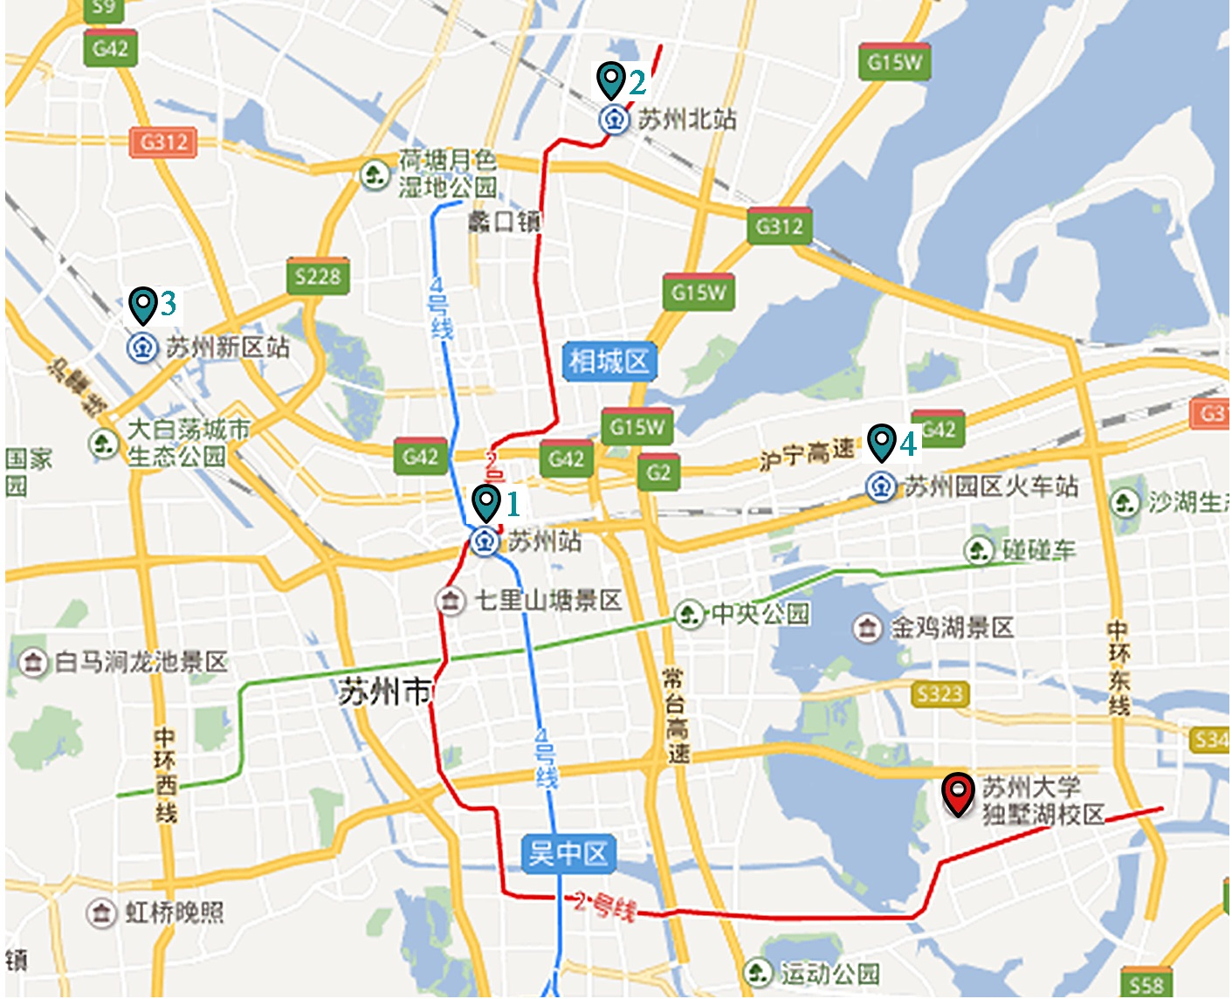

1.苏州站，2.苏州北站，3. 苏州新区站，4. 苏州园区火车站

从苏州北站、苏州站出发：乘坐地铁为2号线在【松涛街站】下车，
4号出口出站往北约一公里到达。
从苏州新区站出发：乘坐34路长线，在【沪宁城铁新区站广场站】上车，【广济桥（石路）站】下车；再换成地铁2号线在【松涛街站】下车，4号出口出站往北约一公里到达。（用时约两个小时。建议打车。）
从苏州园区火车站出发：乘坐115路，在【沪宁城铁园区站】上车，【苏大公寓南区站】下车。（用时约1小时10分钟。建议打车。）

苏州大学独墅湖校区地图↓

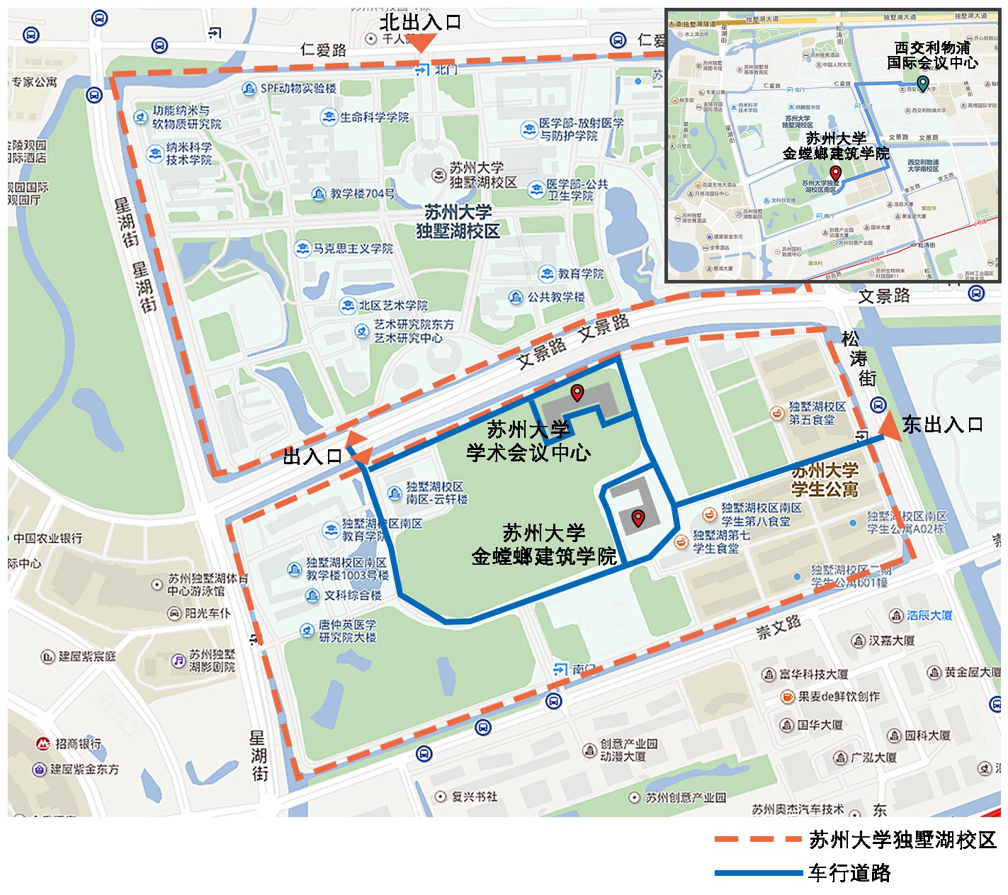

苏州大学独墅湖校区：分为北区和南区，苏州大学金螳螂建筑学院位于南区，距离东门入口最近。学术交流中心位置如图。

酒店距离及出租费用：步行1.3公里，10分钟。车费10元。

苏州市历史建筑与街区图↓

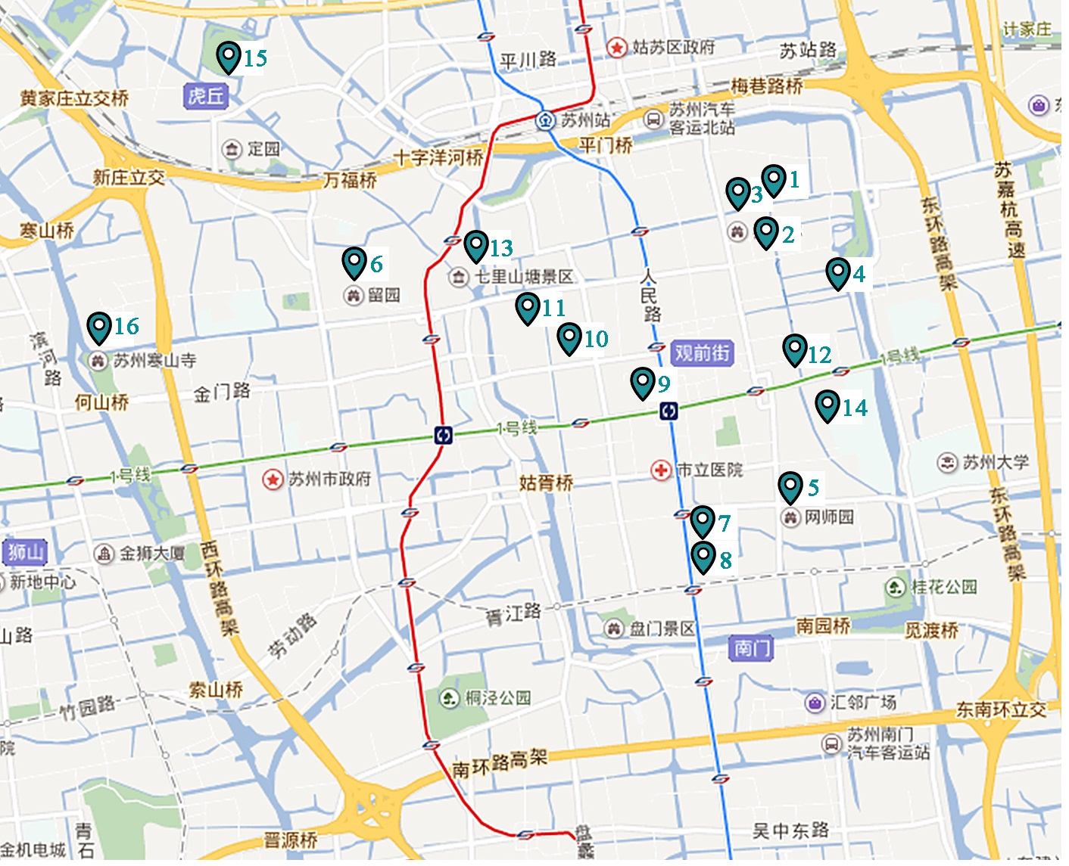

标注点：1.拙政园 、2.狮子林、3.苏州博物馆、4.耦园 、5.网师园 、6.留园、 7.可园、8.沧浪亭、9.怡园、10.环秀山庄、11.艺圃、12.平江历史文化街区、13.山塘街、14.苏州大学本部、15.虎丘、16.寒山寺

生活贴士
TIPS

学校周边银行
1)交通银行：
独墅湖校区内：北区东门食堂西侧（ATM机）。
独墅湖校区外：邻里中心翰林大厦东南。
2)中国银行：
独墅湖校区外：邻里中心翰林大厦麦当劳前（ATM机）、西交利物浦大学文星广场肯德基对面（ATM机）。
3)建设银行：
独墅湖高等教育区文汇广场（ATM机）。
4)工商银行：
西交利物浦大学文星广场肯德基对面。
5)农业银行：
文星广场电子屏幕下（ATM机）。

出行
1)苏州大学独墅湖区地址：苏州市工业园区仁爱路199号。
2)地铁
地铁：地铁2号线，松涛街站或月亮湾站4号口下车，往北步行一公里左右到达。
3)公交
1.北门（炳麟图书馆大门）地址：苏州市仁爱路199号，邮编215123，公交站台【中科大】
公交线路：166路, 178路, 180路内环, 180路外环, ,218路, 快线2号。
2.北区东门地址：江苏省苏州市吴中区松涛街，公交站台【苏大公寓北区】
公交线路： 110路内环, 110路外环, 118路, ,120路内环, 120路外环 ,177路。
3.南区东门地址：江苏省苏州市吴中区松涛街，公交站台【苏大公寓南区】
公交线路：118路, 120路内环120路外环, 177路。
4.北区南门或南区北门地址：江苏省苏州市吴中区文景路，公交站台【苏大公寓北区南】、【独墅湖体育馆东】
公交线路：110路内环, 110路外环, 146路。
5.文星广场地址：江苏省苏州市吴中区仁爱路，公交站台【西交大】
公交线路：115路, 128路, 142路,146路, 16路, 178路, 180路内环, 180路外环, 228路, 812路,快线2号,夜2路。

苏州特产
1)碧螺春茶：中国十大名茶之一，俗名“吓煞人香”。康熙南巡路过苏州，品茶后大加赞赏。因此茶采自清明、谷雨时节，被赐名为“碧螺春”，并列为贡品。
2)苏州丝绸：中国是丝绸之乡，而苏州是丝绸之府。浩瀚的太湖孕育了悠久的蚕桑文化。早在2000多年前，苏州地区就有植桑、养蚕，以及缫丝、捣棉的生产活动。明清时代，苏州的丝绸已经名扬海外，苏缎与云锦、杭罗被列为中国东南地区的三大名产，还通过丝绸之路，远销世界各地。
3)苏绣：苏绣的历史可追溯到2600多年前的春秋时代，苏绣与湖南的湘绣、四川的蜀绣、广东的粤绣并称为“中国四大名绣”。苏绣的题材以人物、山水、花鸟、动物为主，有绣片、册面、屏条、屏风等。新中国成立后，苏州艺人成功地创造了双面绣，其代表作是“双面猫”。
4)宋锦：“锦”是一种高级丝织品，苏州出产的宋锦与南京的云锦、四川的蜀锦并称为“中国三大名锦”。其织造工艺考究，经丝有面经和底经两重，故又称“重锦”。
5)苏式蜜饯：苏州制作蜜饯的历史可上溯到三国时代，清代是苏式蜜饯的鼎盛时期，历来是“宫廷食品”。苏式蜜饯现有160多个品种，以金丝蜜枣、奶油话梅、金丝金桔、白糖杨梅、九制陈皮最为著名。
6)苏式糖果：苏式糖果享誉中华，有明货、炒货、软糖、特味4大类150多个品种，如松子糖、粽子糖、花生糖、三色松子软糖、脆松糖、松子南枣糖等，其中以采芝斋独家生产的粽子糖最为有名。
7)太仓肉松：太仓肉松纤维细长，品质柔软，颜色金黄，味道鲜美，入口即化。它以鲜猪后臀尖精肉为基本原料，经切条、煮松、炒松、搓松4道工序制成。
8)太湖银鱼：春秋战国时期，太湖就盛产银鱼。清康熙年间，银鱼被列为贡品，与梅鲚、白虾并称为太湖三宝。银鱼形似玉簪，色如象牙，软骨无鳞，肉质细嫩，味道鲜美，营养丰富，含有蛋白质、脂肪、铁、核黄素、钙、磷等多种成分。
9)桃花坞木刻年画：苏州的桃花坞木刻年画、天津杨柳青木刻年画和山东潍坊杨家埠的年画并称“中国三大木刻年画”。桃花坞年画始于明末，距今已有350多年的历史，最早的作坊在苏州桃花坞街上，因而得名。清雍正、乾隆年间盛极一时，与杨柳青年画并称“南桃北柳”。

苏州特色小吃
1)采芝斋
地区：观前街地区
2)黄天源
地区：观前街地区
3)哑巴生煎
地址：临顿路温家岸12号
4)得月楼
地址：观前街太监弄43号
5)朱鸿兴面馆
地址：宫巷108号(碧凤坊口)
6)松鹤楼
地址：太监弄72号(近玄妙观)
7)同得兴面馆
地址：十全街624号(近凤凰街)
8)裕兴记面馆
地址：西北街11号(近朱鸿兴面馆)

致谢
ACKNOWLEDGEMENTS

2017（第十六次）建筑与文化国际学术讨论会经过半年的筹备工作，在主办单位、承办单位、合办单位、协办单位、相关媒体和与会代表的共同努力下顺利召开。本次会议共收到论文摘要 150余篇。经过会议学术组的初审及审稿委员会的审稿，最终共计 108篇论文被会议录用发表并将优选出版。27篇论文推荐为优秀论文，将在大会分论坛宣讲交流。 感谢大会组委会和承办单位的工作人员，是他们的辛勤劳动和积极筹备使得本次会议得以顺利召开；感谢协办单位对本次会议的大力支持；感谢各位作者，是他们为大会提供了自己的研究成果，这是他们辛勤汗水的结晶；更要感谢那些默默无闻的志愿者，是他们将这种奉献、友爱、互助、进步的志愿精神在本次大会上体现的淋漓尽致。 最后，再次表示深深的谢意！期待第十七次建筑与文化国际学术讨论会再相会！

2017（第十六次）建筑与文化国际学术讨论会
承办单位：苏州大学金螳螂建筑学院 筹备小组工作人员名单：

统筹指导：孙磊磊
学术小组：潘一婷、陈培阳 、张玲玲
会务小组：陈星（兼财务）、王爽（兼外联）、费莹、尙婧、陈驰
宣传小组：徐娜、成龙
邮箱管理：钱立、吴凡吉
文本制作：薛长瑜、巩雅洁、徐清清、山朱燕、
李磊、庄涛、王鑫、汪伟、王梦娣
接待小组：志愿者小组

